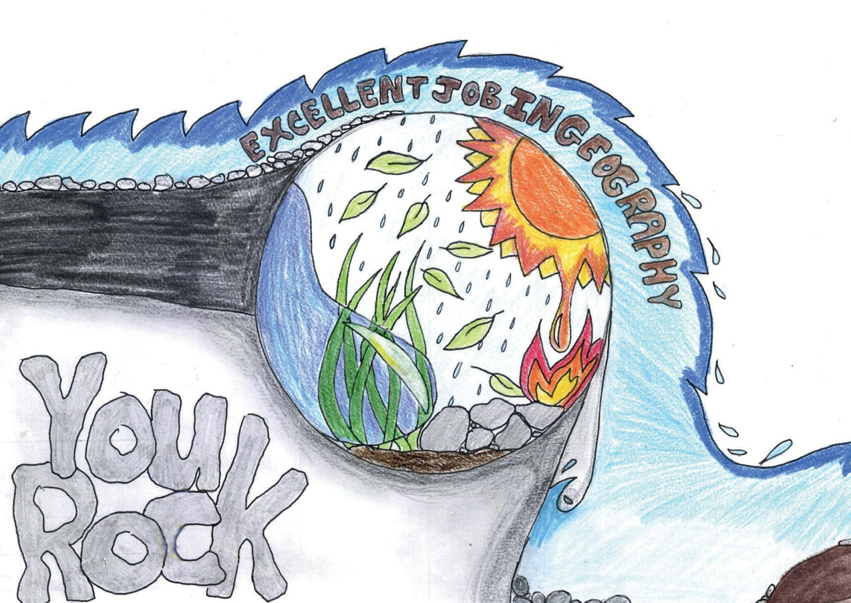



Click here and type name

Address

Address

Address

Address

Click here and type your message into this box

Heaveny Curpen

Mount Carmel Secondary School

